Lab Assignment:

Phonological similarity task:

CogLab displays the data with all three I.V.s:
- how the letters sounded in relationship to each other (similar, dissimilar),
- whether or not there was concurrent articulation in the form of counting (suppression, quiet), and
- position of the item in the list, that is, serial position (1, 2, 3, 4, 5, 6, and 7).

Here is an example:
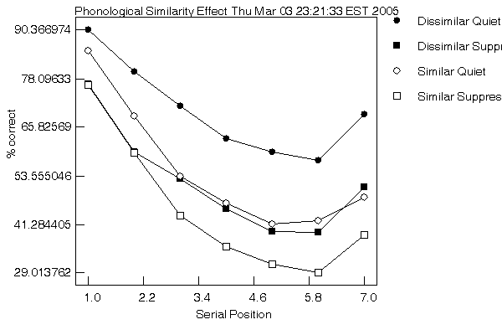

- a. While the graph above is useful to see the recency and primacy effect, it does obscure the similarity and suppression effects. Plot the data as a 2 (similar, dissimilar) x 2 (quiet, suppression).
- Plot your individual data as suggested in 1.a
- a. Was there a main effect of similarity? (explain)
- Was there a main effect of articulatory suppression? (explain)
- Was there an interaction between similarity and articulatory suppression? If so, explain in which direction.

