PSY4500 MW
10/6/04

Brown Peterson Experiment
1.a Plot the data (or print it from CogLab).
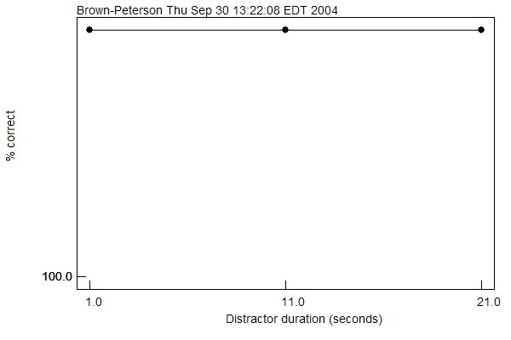
1.b Name the dependent variable/s

The dependent variable was the percent of trigrams that were correctly recalled after the distractor task was completed.

1.c Name the independent variable/s

The independent variable in this experiment was the duration of the distractor task (classifying numbers as even or odd). There were three levels of this independent variable (1, 11, and 21 seconds).

2. a. In the task you completed, the interval between trigram presentation and recall is filled with a secondary task (i.e., the odd/even task). If you had done the memory task without the odd/even task, your performance would probably have been better. Explain why.

Even with the secondary task of classifying numbers as odd or even for varying intervals of time, my performance on the recall task was perfect. However, in theory, an individual’s performance on the memory task (recalling the trigrams) in the absence of the secondary odd/even task, would be expected to be better because of the existence of a short term memory system. An individual’s short term memory holds information for several seconds. However, without the active effort of the participant, the information that is stored in short term memory begins to fades away. Therefore, performing a distractor task, such as classifying digits as odd or even, prevents the participant from rehearsing the trigram. If on the other hand, the task was completed in the absence of the secondary distractor task, the participant would be able to rehearse the trigram throughout the time period between trigram presentation and trigram recall, which would increase the percentage of correct responses.

2. b. In the task you completed, the interval between trigram presentation and recall is filled with a secondary task (i.e., the odd/even task). In such a task, recall accuracy is dependent on the length of the interval. In other words, accuracy is lower for long intervals than for short intervals (e.g., 3 secs vs. 21 secs). Would a long interval (e.g., 21 secs) have a detrimental effect in recall accuracy even in the absence of a secondary task? (yes/no). Justify your answer

In the absence of a secondary task, a long interval should not have an effect on recall accuracy because during the delay, participants can continue to maintain the recency items. Since no new materials are coming in, nothing displaces these items (the trigram in this instance) from working memory. However, if participants are not completely focused on the task at hand, a longer time interval may afford more opportunity for their mind to drift, and then a detrimental effect may be seen in recall accuracy data. However, if the participant remains focused, no detrimental effect should be seen.

