1. Localize the brain in relation to the head (where would eyes, ears, neck, be?)

2. Understand these terms in relation to the brain or image you are seeing
Dorsal (as in ‘dorsal fin’), Ventral, Lateral (as in a ‘lateral pass’), Medial, Anterior, Posterior
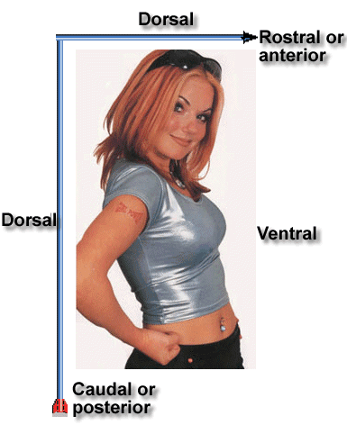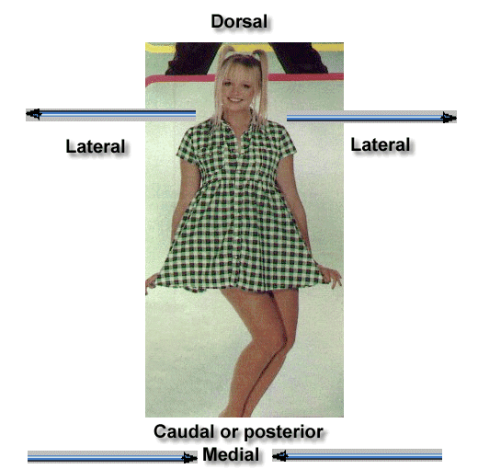
Structure | Function (know a brief description)
Left Hemisphere | XXXXXXXXXXXXXXX
Cerebellum
Lobes (plate 1-2) | Match the following cognitive functions to the lobes that perform them: Motor, Audition, Somatosensory, Vision
Frontal
Parietal
Temporal
Occipital
Sulcus and fissures: | XXXXXXXXXXXX
Lateral Fissure | It separates ______ lobe from _________ lobe
Central Sulcus | It separates ______ lobe from _________ lobe
Brainstem
Spinal Cord
Hypothalamus
Corpus callosum
Pituitary gland
hippocampus

