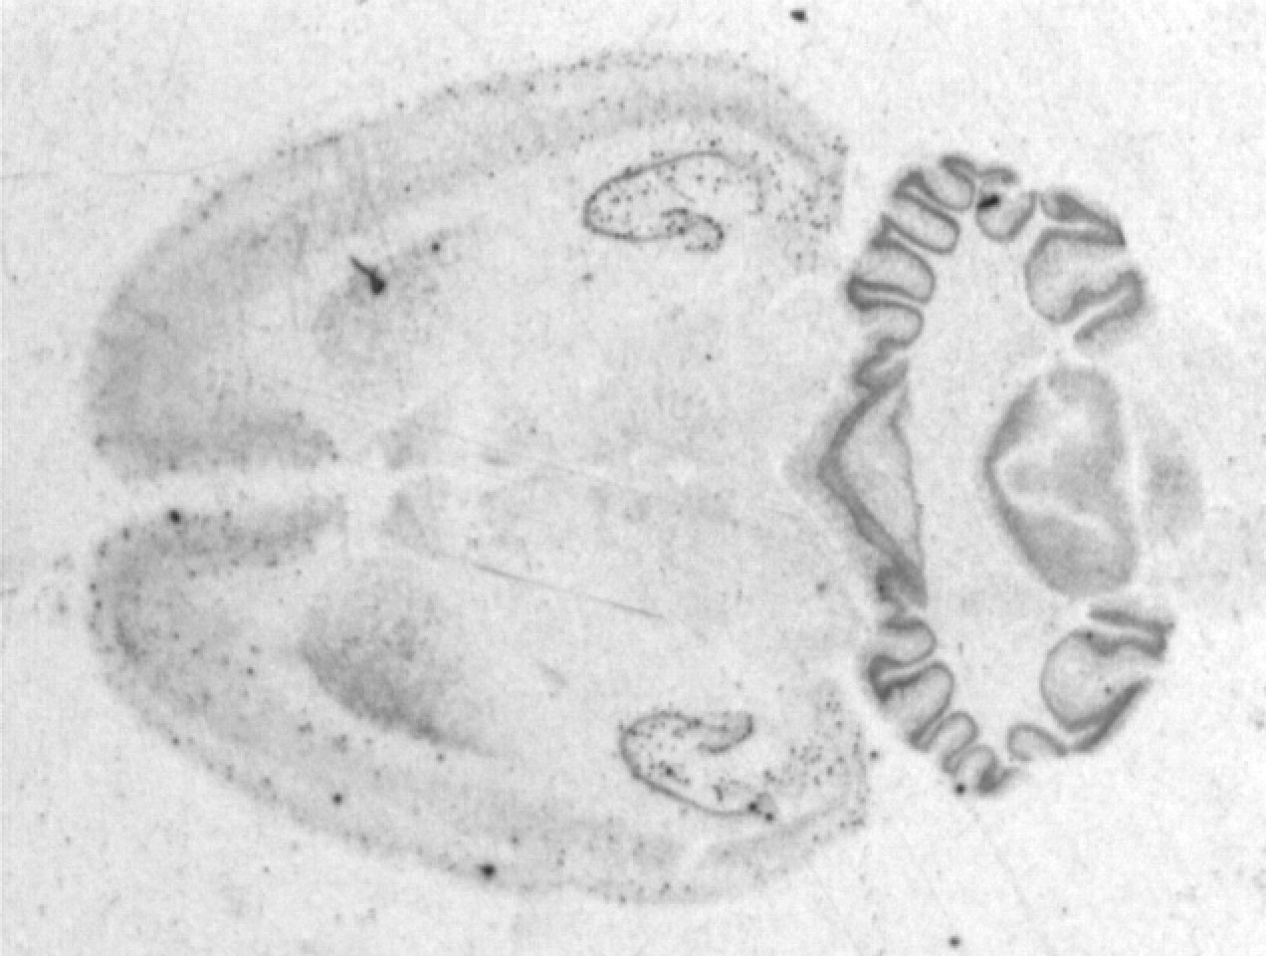
Histology is “the study of tissue”. This covers a rather enormous range of techniques. At their core, all techniques work basically the same way: a visible chemical binds to (different parts of) the nervous system. As a first step, the animal is anesthetized and saline solution (kind like Gatorade) is pumped into its heart to clear all the blood out of the body. Next, formalin is pumped to harden the tissue. The brain is then removed and stored in formalin until processing time. Next, the brain is frozen to hold its shape and placed on a microtome (a kind of meat slicer) that cuts slices as thin as a human hair. Each slice is mounted onto a slide. Next, the slide is stained, and looked under the microscope

Cerebrum.
- Go to the Illinois website and open slide of rat brain (w78f). Zoom by opening the links until you see the pyramidal cells with their dendrites (arrows will appear showing you where the dendrites are if you go to the top of the image and scroll to see labels).
- In the Iowa website, go to Cerebral cortex-silver stain (#24). In this rather beautiful slide, distinguish white and gray matter and note neuronal processes (fine black lines).

Spinal Cord.
- Go to the ‘Vertebra-disk’ slide in Iowa website and click “Visible human: thoracic spine, spinal cord” in the left side bar to see a macroscopic cross-sectional view of the spinal cord (bright white structure of penny size), surrounded anterior by the vertebra and posterior by the muscle.
- Next, find the slide of ‘spinal cord (#19)’ In the anterior horn of the spinal cord, increase the magnification until you find motor neurons. These large neurons are sometimes damaged by polio.
- Still in Iowa, go to the slide ‘spinal cord smear: (#16) in which you can find some beautiful multipolar neurons.

Cerebellum.
- Start in the Iowa website and click in the first slide of ‘Brain, cerebellum’. In the left sidebar, click the supplemental images to see macroscopic views of the cerebellum. The surface of the cerebellum has many furrows which divide it into lobules, each of which has a superficial layer of gray matter (cortex) and a core of white matter.
Supplemental Images
Gross: normal cerebellum
Visible human: pineal gland, cerebellum
Visible human: cerebellum

- Next, click ‘view 1’ in the side bar for a microscopic view. The cerebellar cortex has three layers. There is an outer molecular layer (pale pink) and an inner granule layer with many small, densely packed dark staining cell bodies. Between the two layers are interspersed large, prominent neurons – the Purkinje cells.
- Go to the Illinois website, and scroll until you find the cerebellum of the rat (w79b). Open this image and its links by clicking inside of the square, until you find the Purkinje cells. Notice their dendrites. Go back to the Iowa website, open cerebellum – silver stain (#26) and find Purkinje cells and their dendrites by increasing the magnification power (To change the power of the image go to the top right inset of the display)

