The Vision Lab (psy1000).

1. Dissection of Cow eyes: Go to this website. Make a sagittal cut of the eye with the knife. As you identify each structure in the anatomical preparation, write down its name in the figure below:
· Sclera: this is the white of the eye. Functions: protection, reflection of light
· Cornea: initial bending of the light
· Iris: this is the 'color' of our eyes. It determines the pupil size
· Lens: bends and focuses the light very precisely.
· Retina: at the back of the eye; it contains photorreceptors
· Optic disk: where the axons form the ganglion cells exit the eye
it creates a 'blindspot' in out visual field
· Optic nerve: Once you localized it, make a sagittal cut of the optic nerve and
observe that the optic nerve originates in the optic disk
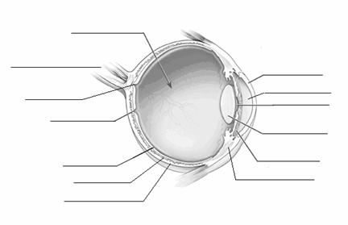

2. Macroscopic identification of structures of the Visual system (plastic model)
· Optic nerve
· - primary visual cortex
· - ventral pathway: object recognition, color, shape
· - dorsal pathway: motion perception, spatial location, visual spatial attention

3. Psychophysics demonstrations

Blindspot excercise. Part 1. Close your right eye and fix your gaze on the 0 below. Hold the book about 6 inches from your face. Move the book slowly toward your face and then away, always keeping your left eye fixed on the black dot. When the X falls on your blindspot it will disappear. Note that the blindspot is lateral to the eye (i.e, to the left of the left eye, to the right of the right eye). This is so because the optic disk is in the medial part of the retina (see figure in your book).

X 0

Blindspot excercise. Part 2. Repeat the exercise as before, fixing your gaze on the 0 below. Q: What do you see when the gap in the bars fall onto your blindspot?

0

A: Most people report seeing seeing a continuous bar. This is evidence that the brain can generate experiences that correspond to a location in space, even in the absence of direct sensory input from that region

PsyCog (CD)

Fig A.3.1 Color Negative Afterimage: “Click the ‘adapt’ button, then stare at the black dot in the display. When the pattern vanishes after 15 seconds,
- What do you see in the white space?
- When you move your eyes, does the afterimage stay in the same location, or does it move with your eyes? Why do you think this happens?
- After a period of adaptation, look at a distant white wall or out the window at the sky (and keep looking for 10 secs without moving your eyes). Does the afterimage appear the same size or much larger? Why do you think this happens?

Brightness Contrast:
- Fig A.4.1. Which of the four small gray squares is brightest? The lighter the background the darker the small square appears. Click and drag the squares to check

Motion Aftereffect Fig A.5.1

Ex. A.8.6 Ebbinghaus Illusion. The center circles in the two displays do not appear to be the same size. This is a contrast illusion involving object size. Objects surrounded by larger objects appear smaller than same-size objects surrounded by smaller objects.

