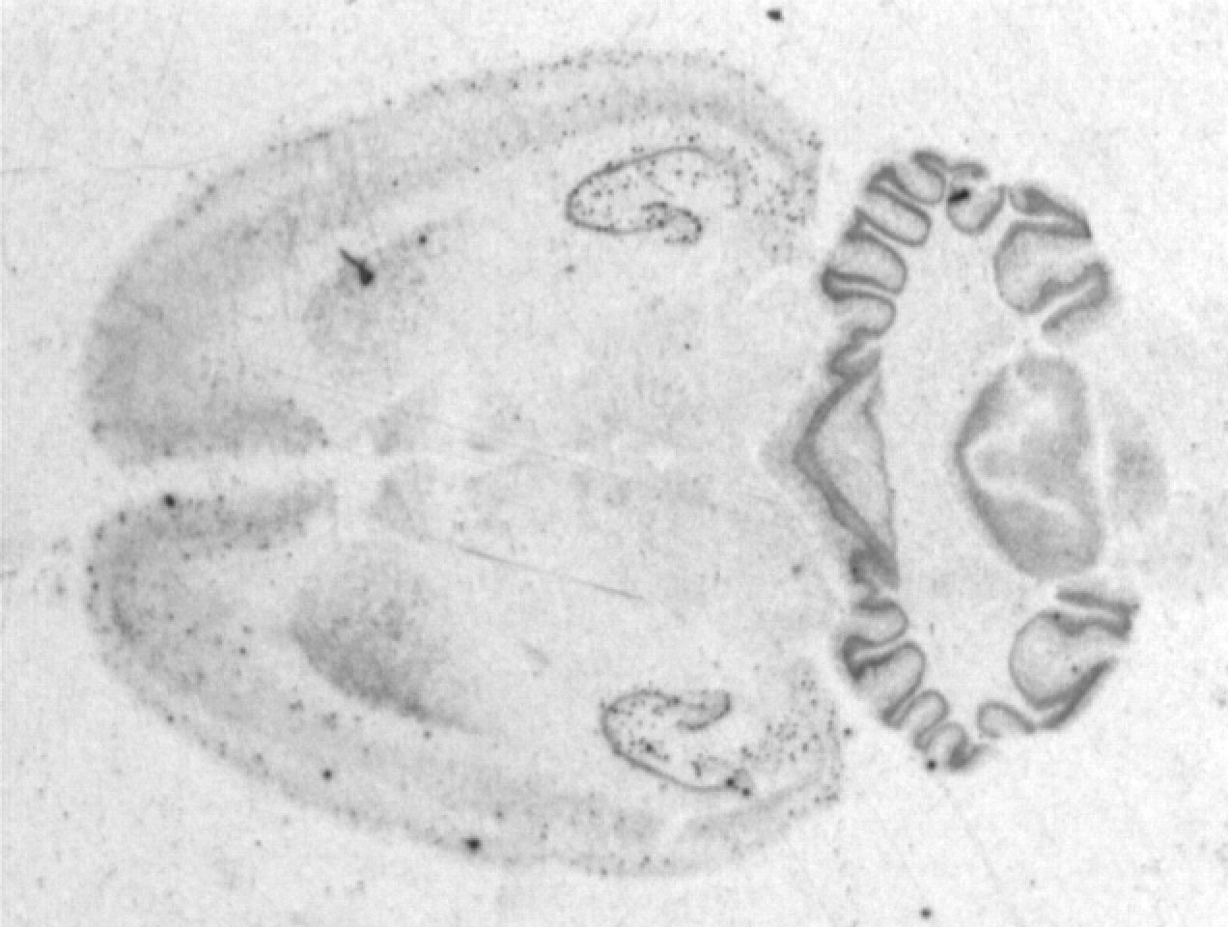
Histology is “the study of tissue”. This covers a rather enormous range of techniques. At its most sophisticated, histological techniques can be used to discover which genes are being transcribed in a tissue (e.g., through in situ hybridization) or what proteins are expressed (e.g., via immunohistochemistry). Histological techniques are also used to describe the microstructure of neurons (electron microscopy), the macrostructure of neurons (using, for example, the silver impregnation stain), or the connectivity of the nervous system (track tracing, Nissl staining). Other specialized techniques allow study of the time course of development of structures (e.g., 5-bromo-2'-deoxyuridine [BrdU] staining, a marker of mitosis) or evidence of their degeneration (e.g., glial fibrillary acidic protein [GFAP] staining).

While these would all fall under “study of the tissue”, histological techniques are also routinely used as accessory manipulations in lesion, pharmacological, or electrophysiological studies. An electrode recording neural activity or a cannula delivering intracerebral drugs can also inject a dye used later to verify the position of the electrode or cannula in the brain. A brain may be analyzed later to quantify the location and extent of an electrolytic or excitotoxic brain lesion. Thus, even in labs that do little tissue study per se, histological techniques are often used.
(from Steve St. John, at Rollins College)

Steps of Preparing a Histological Stain of a Rat Brain
1- Perfusion: a living animal (usually a rat) is deeply anesthetized and saline is pumped into its heart in order to clear all the blood out of the body. Next, formalin (37% formaldehyde) is pumped through its circulatory system in order to fix the tissue. This hardens the tissue and prevents it from decomposing. The brain is then removed and stored in formalin until processing time.
2- Slicing & Mounting: the brain is frozen or embedded in wax to hold its shape and then placed on a microtome in order to slice thin sections (~50 microns thick = 1/20 of a millimeter, the thickness of “fine” human hair) along some plane (coronal, sagittal, horizontal). Typically, a coronal plane is used. The microtome is roughly equivalent to a meat slicer. As each slice is removed it is stored in saline or alcohol and then mounted onto a slide. This link shows the slicing and mounting of the famous patient HM, http://thebrainobservatory.ucsd.edu/content/leaf-through-brain , and of a seal http://thebrainobservatory.ucsd.edu/content/comparative-anatomy
3- Staining: Process the slides through a staining procedure which involves chemically “tagging” some portion of the nervous system so that it stands out from the rest. The specific process usually involves “hydrating” the slides (alcohols and waters), staining, dehydrating, clearing, and finally cover-slipping to protect slices from handling.
4- Observation: Slides are examined under a microscope and evaluated for whatever anatomical parameter you are interested in. Sections are referenced to a brain atlas in order to determine which structures are represented on each slide. Things that are frequently assessed are white matter/grey matter, cell layers, damage such as gliosis (scarring) or track marks in the case of trying to localize a microinjection or electrode implant. THIS IS THE STEP WE WILL FOCUS ON DURING LAB.

- Human Brain: http://thebrainobservatory.ucsd.edu/content/public-brain-atlas

- Histology of hemorrhagic brain (due to traumatic brain injury) http://www.youtube.com/watch?v=VdhcFTxm6DI Watch first 90 secs of this video.
- What types of nervous cells do you identify? What part of the cell is stained? Describe
  - Cell type: ___________ Part of cell: ____________
  - Cell type: ____________ Part of cell: ___________
- Is it possible to ‘see’ other parts of the cells? What would you need?

3. Cerebellum. Using the histology websites, identify the underlined structures.
Start in the Iowa website and click in the first slide of ‘Brain, cerebellum’. In the left sidebar, click the supplemental images to see macroscopic views of the cerebellum. The surface of the cerebellum has many furrows which divide it into lobules, each of which has a superficial layer of gray matter (cortex) and a core of white matter.
Supplemental Images
Gross: normal cerebellum
Visible human: pineal gland, cerebellum
Visible human: cerebellum
Next, click ‘view 1’ in the side bar for a microscopic view. The cerebellar cortex has three layers. There is an outer molecular layer (pale pink) and an inner granule layer with many small, densely packed basophilic staining cell bodies. Between the two layers are interspersed large, prominent neurons – the Purkinje cells. The most superficial layer, the molecular layer, has few neurons, many unmyelinated nerve fibers, and many dendrites of Purkinje cells (not visible with this stain). Moving further from the surface, you will see another layer of white matter, composed of axons and dendrites going to/from the cerebellar nuclei.

Go to the Illinois website, and scroll until you find the cerebellum of the rat (w79b). Open this image and its links by clicking inside of the square, until you find the Purkinje cells. Notice their dendrites. Go back to the Iowa website, open cerebellum – silver stain (#26) and find Purkinje cells and their dendrites by increasing the magnification power (To change the power of the image go to the top right inset of the display)

4.Cerebrum. Using the histology websites, identify the underlined structures.
Start in the Iowa website, finding the slide of ‘Brain, cerebral cortex (#23)’. In the left sidebar, click ‘Gross: normal’, for a macroscopic view of the human brain. You can see a cortex of gray matter and a central area of white matter (this is reversed from the spinal cord, where the gray matter is localized internal to the white matter). The gray matter has mostly cell bodies and dendrites, while the white matter has mostly axons and myelin. The cerebral cortex has many convolutions consisting of sulci (small grooves or valleys) and gyri (hills).
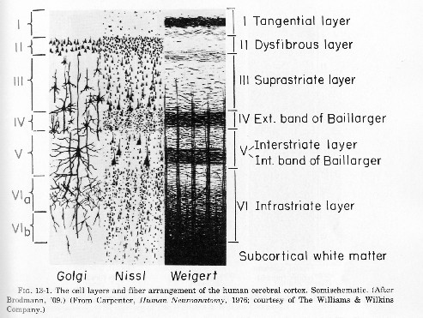
Next, click ‘view 1’ in the side bar for a microscopic view. You’ll see two gyri separated by a vertical sulcus. To change the power of the image go to the top right inset of the display. Using a low power of 2.5x, the arrangement of neurons within the cortex gives it the appearance of having several layers. You will not be able to identify each layer but rather notice that there are layers. The third layer from the outside consists of the largest neurons (pyramidal cells) which are best observed at a power of 10x.
In the Iowa website, go to Cerebral cortex-silver stain (#24). In this rather beautiful slide, distinguish white and gray matter and note neuronal processes (fine black lines).
Next, go to the Illinois website, and scroll until you find the pre-postcentral cerebral cortex of a monkey (slide w78a). Once again, you will see two gyri separated by a sulcus. Open this image and its links by clicking inside of the square, until you find the pyramidal cells (aka giant betz cells).
Still in Illinois, open slide of rat brain (w78f). Zoom by opening the links until you see the pyramidal cells with their dendrites (arrows will appear showing you where the dendrites are if you go to the top of the image and scroll to see labels).

5.Spinal Cord Using the histology websites, identify the underlined structures.
Go to the Illinois website, and scroll until you find the spinal cord of the rat (w80c). Look first at low magnification for overall orientation to the spinal cord, cut here in cross-section (like a salami). Note the location of the white matter relative to the gray; unlike the brain, the white matter is externally located in relation to the gray matter. The gray matter has a "butterfly" shape.

In the Iowa website, find the slide of ‘spinal cord (#19): In the ventral (anterior) horn of the spinal cord, increase the magnification until you find motor neurons. These large neurons are sometimes damaged by polio. Still in Iowa, go to the slide ‘spinal cord smear: (#16) in which you can find some beautiful multipolar neurons.
Finally, go to the ‘Vertebra-disk’ slide in Iowa and click “Visible human: thoracic spine, spinal cord” in the left side bar to see a macroscopic cross-sectional view of the spinal cord (bright white structure of penny size), surrounded anterior by the vertebra and posterior by the muscle.

Do you want to see more? (Of course you do!): Go to this website:
Department of Pathology, Oklahoma HSC http://moon.ouhsc.edu/kfung/jty1/neurohelp/ZNEWBS12.htm#EWBS12Neurons

The simple reflex arc is a key concept in regard to spinal cord function. This arc begins with sense receptors in the skin. When stimulated, the impulse travels down myelinated afferent (sensory) nerve. The sensory nerve enters the spinal cord and synapses with an interneuron in the dorsal horn of the gray matter. This interneuron then synapses with a large efferent (motor) neuron in the ventral horn gray matter of the spinal cord. The impulse then travels down the myelinated axon of the motor neuron, and synapses on the motor end plate at a muscle cell. This reflex arc occurs without sending any information to the brain, and thus it can occur without conscious perception of sensation.

