Chapter 2. PART A. Neurons, Glia, Blood-brain barrier
Highlighted sections
Intro
Neurons – Basic Structure
Glia
Blood-brain barrier

Study Questions
- Label the four principal structures of the neuron shown below.
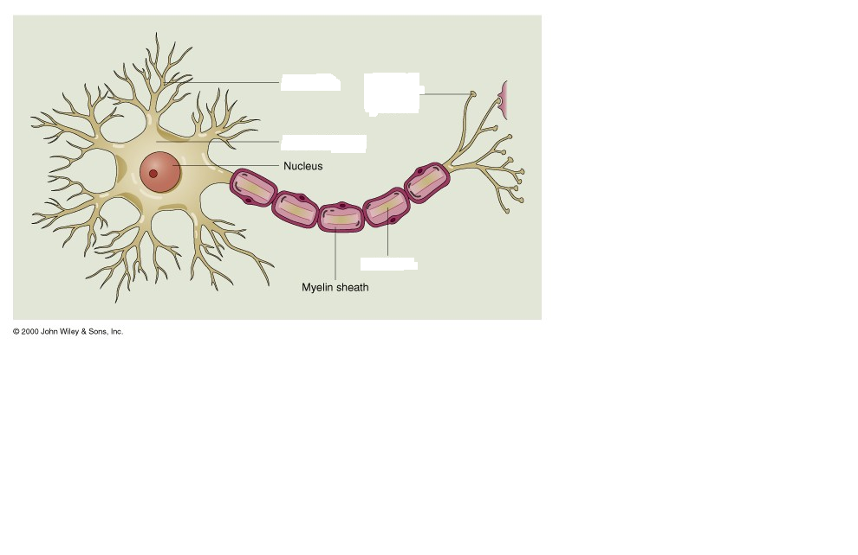

2. describe the nature of synaptic connections in your own words.

3. List the two types of glial cells

4. What is the main function of the oligodendrocytes?

5. a) describe how the oligodendroglia form the myelin sheath around an axon. Be sure to mention the modes of Ranvier in your answer.

6) Is the brain tinted when dye is injected into an animal’s bloodstream? (Bradbury, 1979). What does this experiment demonstrate about the relationship between the blood and the fluid that surrounds the cells of the brain?

7. Why some substances pass easily through out the blood-brain barrier and other do not.

8. Discuss the uniformity of the blood-brain barrier through out the nervous system and its relationship to the control of vomiting.

9. The lesion of the motor neuron by the polio virus) leads to ___________________ (normal or impaired?) sensation, and a _____________ (Normal? Reduced? Increased?) withdrawal reflex. (L)

10. A spinal cord lesion that disconnects the spinal cord from the brain leads to ___________________ (normal or impaired?) sensation, and a _____________ (Normal? Reduced? Increased?) withdrawal reflex. (L)

Key words: Sensory neuron; Motor neuron; Interneuron; Central nervous system; Peripheral nervous system; Dendrite; Synapse; Axon; Terminal button; Neurotransmitter; Membrane; Chromosome; Gene; Enzyme; Glia; oligodendrocyte; node of Ranvier; Schwann cell; Blood-brain barrier

