PSYCHOLOGY 4200. Fall 2005
Anatomy exam

Name ______________________

Don't make wild guesses. Bad mistakes will be penalized.

Microscope
- Identify ____cross-section spinal cord__

Brain Model A
- Identify ____thalamus_____
- Identify basal ganglia – caudate nucleus
- Identify and __hippocampus
  - Name Function ___memory_______
- Identify __insula__________

Human Brain
- Identify ___olfactory bulb____
- Identify ____superior colliculus_____
- Identify and _____pituitary gland_
  - Name Function ______hormonal release___
- Identify _______corpus callosum_
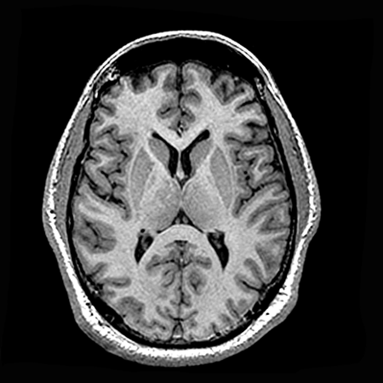

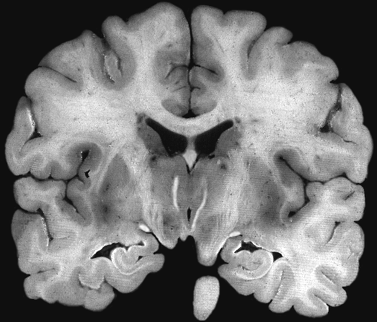
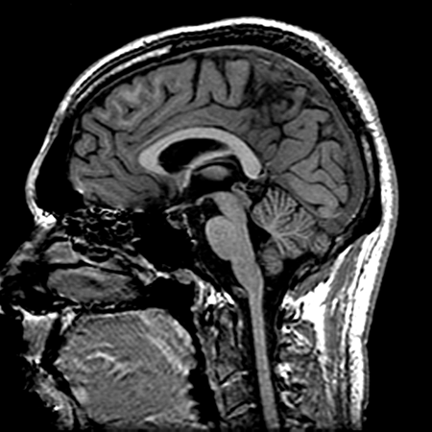
Indicate which cut this is

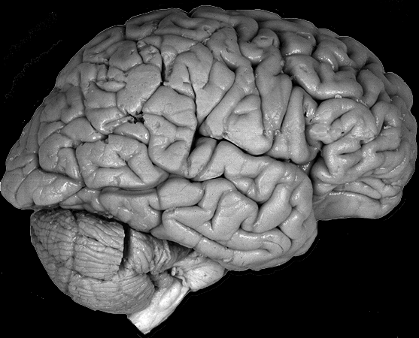

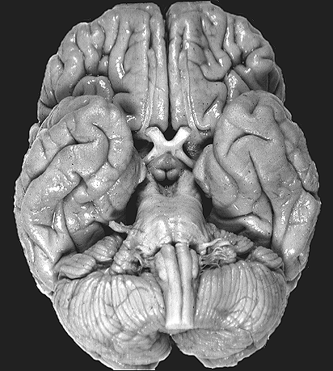
Indicate which type of cut this is

