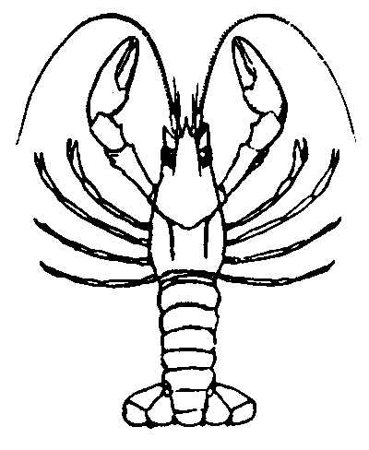
As the traveling signals of nerves and as the localized changes that contract muscle cells, action potentials are an essential feature of animal life. They set the pace of thought and action, may constrain the sizes of evolving anatomies and enable centralized control and coordination of organs and tissues.

-- http://en.wikipedia.org/wiki/Action_potential#Underlying_mechanism

This hand-out draws heavily from instructional material developed by Professor Richard F. Olivo for his Neurophysiology course at Smith College. You can access more information from his website: http://www.science.smith.edu/departments/NeuroSci/courses/bio330/labs/L7cns.html

I. Overview
The crayfish abdominal nerve cord has been widely investigated because of its relative simplicity. The cord consists of six ganglia (a ganglion is a cluster of neuron cell bodies). From each ganglion, three bilateral (left & right) pairs of nerves ("roots") innervate the muscles and sensory receptors in that abdominal segment. In this experiment, we will record from whichever of the roots gives the best recording. The crayfish motoneurons are tonically active – this means they generate spontaneous spikes that we will watch and listen to. The function of this tonic motor activity is to produce a continuous low level of muscle tension to keep a joint stiff. It may also provide "synaptic readiness" for sudden increases in activity.
We will use suction electrodes to record from the roots. The advantage of suction electrodes is that the nerve can remain immersed in saline; it is not necessary to lift the nerve branch into air. Instead, the nerve to be recorded from is cut, and the cut end is sucked into the electrode. The electrode must fit the nerve tightly to produce a good recording. After placing the electrode, our goals today will be:
- to observe spontaneous single-unit activity in a motor nerve
- to observe the responses to a neuroactive drug (nicotine) that mimics ACh and elicits a long burst of spikes.
We will observe such activity using an oscilloscope. An oscilloscope is an instrument for displaying electrical signals (the vertical scale) against time (horizontal scale). It does this by sweeping a bright spot across the screen and modulating the position of the spot. Typically, oscilloscopes are used for viewing electrical potentials from nerves.

II. A review of resting and action potentials

Equilibrium potential for any ion is the electrical potential across the membrane that exactly offsets the tendency of that ion to diffuse from regions of high to low concentration. For potassium ions in particular, there is a tendency to diffuse from inside the cell (where they are in high concentration) to the outside (where they are sparse). After a relatively few K+ ions have left the cell, however, the cell will have become negative enough inside so that K+ ions are attracted into the cell. The rates of entry (attracted by the negative interior) and of exit (diffusing from high to low concentration) will be exactly balanced at equilibrium.

For nerve cells, the membrane potential at rest is very close to the potassium equilibrium potential. This occurs because the permeability to potassium is much higher than the permeability to other ions at rest, and thus potassium ions cross the membrane most freely and establish their own equilibrium conditions.
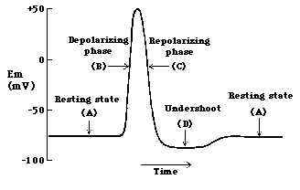
Action potentials are triggered by an initial depolarization to the point of threshold. This threshold potential varies but generally is about 15 millivolts above the resting potential of the cell, occuring when the inward sodium current exceeds the outward potassium current.
The depolarization phase of an action potential is due to the opening of voltage-gated sodium channels. Sodium ions are positively charged. When a voltage-gated sodium channel positively charged ions move into the cell. Voltage-gated sodium channels automatically gate shut after about a millisecond. Cells normally keep the concentration of potassium ions high inside cells. When voltage-gated potassium channels open, positively charged potassium ions move out of the cell, causing the membrane potential to return to a negative inside potential. (For more info, see the website for links to great animations!)
III. Method: Watch the video!! at Smith College website http://www.science.smith.edu/departments/NeuroSci/courses/bio330/labs/L7cns.html
the link is named “Motor units in Crayfish Abdominal Ganglia” in the left side three quarters down. What follows here are those instructions in written form
*Begin the experiment by obtaining a crayfish and chilling it in an ice-water mixture to slow its movements to a rate you find acceptable.
*Cut off the abdomen ("tail") as close to the thorax as possible.
*Pin the abdomen ventral side up in a deep dissecting dish and add crayfish saline to cover it. *Starting at the cut end of the abdomen, make long incisions on either side (like the video showed). Use caution because the ventral nerve cord lies just below the exoskeleton. (However, if you accidentally cut the nerve roots on one side, it is not a problem. You will want to cut some of them anyway to pick up with the suction electrode.) Extend the incisions almost to the last segment.
*Lift the exoskeleton cautiously, peeking under it to make sure that the nerve cord is not adhering to it (if it does adhere, gently scrape it free with a scalpel).
*Cut away the flap of exoskeleton to expose the nerve cord and ganglia in the first four segments. Make every attempt to keep the nerve roots intact on the side opposite to your first cut. *Locate all three roots of the third or fourth abdominal ganglion. You will find that the roots have been cut by your incisions. The piece of each root still attached to the ganglion is the piece to be picked up in a suction electrode.
*In preparation for recording, ground the saline of the bath by attaching a clip lead between a ground point and a small length of silver wire that is dunked in the bath and fastened with tackiwax to the lip of the dish. Do not immerse the clip itself or you will get an unstable baseline.
*Lower the suction electrode into the saline and draw a little saline into the tip. Eliminate any air bubbles that lie between the tip and the internal wire; they would prevent electrical contact between the nerve and the wire.
*Position the tip of the electrode so that it touches the cut end of a root, and gently draw the end of the root into the suction electrode. Keep trying until you get something!
IV. What am I seeing?
The oscilloscope is displaying spontaneous motor unit activity recorded with a suction electrode on whichever root of a crayfish abdominal ganglion you have isolated. Spikes of different sizes represent different motor axons.
Since the fluid outside a neuron is connected to the other body fluids, at rest its electrical potential is zero. When an action potential passes by, some positive ions leave the extracellular fluid and enter the neuron. For the brief moment of the action potential, the fluid outside the neuron has a deficit of positive ions. A deficit of positive ions is the same as an excess of negative ions. Thus, an electrode outside a neuron sees a negative-going change in potential when an action potential sweeps by. In addition, if two nearby extracellular electrodes (such as the two hooks in our experiment) are connected to the two inputs of a differential amplifier, each electrode will see the same action potential, but with a slight delay as the action potential travels by. The amplifier inverts one of the signals, turning the negative-going spike into a positive potential.

V. Testing the action of nicotine

In low concentrations, nicotine mimics the action of acetylcholine at postsynaptic receptors. As the concentration is increased, nicotine's action changes from activating the synapses to blocking them. Because nicotine's blocking action is nearly irreversible in this preparation, you will have only one chance to do this part of the experiment.

Find a good spot on the nerve to record from and add 1 or 2 drops of nicotine. Be patient – watch and listen!

VI. Please clean up your area before leaving!!

