Psychopharmacology Lab:
The effect of alcohol and amphetamins in the exploratory behavior of rats

Background for our Study
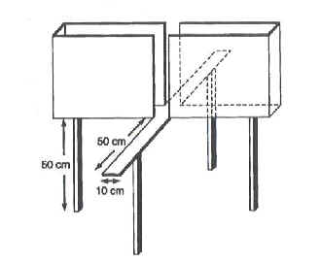
At low doses, alcohol reduces the discomfort of anxiety (i.e., it has an anxiolitic effect). After a drink or two, we feel more comfortable expressing our love to the girl sitting next to us, insisting despite her clear rejection. That is, we feel comfortable exploring uncharted territory and we are insensitive to her punishment. The same is true for rats. When sober, rats have a tendency to avoid brightly lit, open, elevated spaces, (uncharted territory). They also quickly stop behavior for which they are punished (e.g., by electric shock). To study the effect of alcohol in the exploratory behavior of rats, Wilson et al. (2004), used a behavioral measure called the plus-maze. In this maze, rats are elevated off the floor a few feet and must navigate to the ends of four arms to get food. Two of the arms have walls and two do not. Rats generally spend more time on the arms with walls, presumably because the open arms trigger an anxiety response. Alcohol and benzodiazepines bias rats to spend more time in the open arms, presumably by reducing their anxiety to open spaces.

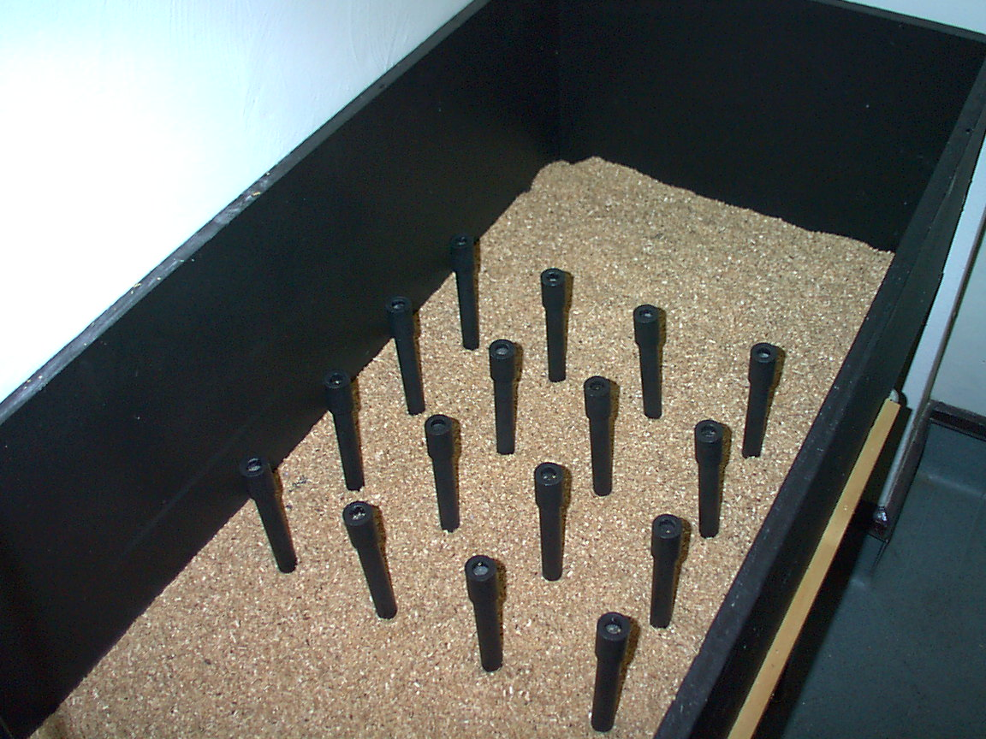
Dr. Mike Brown, a psychology professor at Villanova University interested in animal behavior, often uses a pole box in his studies. In a pole box, rats are free to move from pole to pole in search of food. He has observed that rats have a strong tendency to stay near the perimeter of the poles. The reason, he speculates, is that rats feel safer around the edge of the box rather than in the middle of it. If his hunch is right, then it stands to reason that the administration of alcohol will increase, the amount of time that rats spend visiting the center poles.

Our Goal

We wish to expand the findings of Wilson et al. (2004) and address the effects of ethanol on the risk-taking behavior in rats using the pole box. No experiment has ever researched the effects of alcohol in exploratory behavior in this way and our results will offer a novel piece of valuable information. We will compare our ‘drunk’ rat to a rat that received placebo, and to rat that was given amphetamine.

Method
Rats will be given an i.p. injections 10 minutes before behavioral testing of one of the following:
1 g/kg Saline, .5g/kg Ethanol, 1.5g/kg Ethanol, or 3mg/kg Amphetamine.

Do some rats visit the inside poles more than the outside poles within a 3 minute period? You must devise a way for your group to run and record each rat’s pole box behavior and answer this question. Remember to keep everything but the injections the same!

Discussion
What are the possible results we could obtain?
What could they all mean?
Which result do you predict?

The anxiolitic effect of alcohol is mediated by alcohol’s agonist effect on GABAa receptors, and alcohol’s antagonist effect on NMDA receptors. Many tranquilizers and sleeping pills, such as benzodiazepines (Valium) and barbiturates – also have an agonist effect in the GABA receptors. For this reason, you are advise not to drink alcohol on the GABA receptor.

