Chapter 7 – Audition, the body senses, and the chemical senses
Figures: 2, 3, 4, 5, 12, 13, 14, 15, 18, 25, 31, 33
Keywords: Pitch, Hertz, Loudness, Timbre, Cochlea, Basilar membrane, Tectorial membrane, Tonotopic representation, Place code, Cochlear implant, Rate code, Phase difference, Phantom limb, Umami

Audition

- What makes a sound? (see fig 7.1)
- Explain the following characteristics of sound: pitch (be sure to use hertz in your answer), loudness, and timbre.
- Name the parts of the ear shown below.
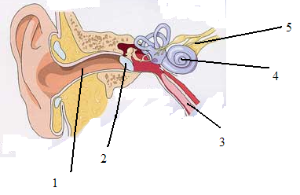

- Describe the connections between the basilar membrane and the auditory cortex. How do we refer to the relationship between these two structures? Why?
- Explain the notions that moderate to high frequencies of sound are detected by place coding?
- Summarize the structure and function of the cochlea and the manner in which vibrations caused by sounds are transduced into neural impulses.
- Discuss human pitch sensitivity and two possible mechanisms by which frequency may be encoded in neural signals
- Name and describe two mechanisms by which the auditory system codes stimulus location. Describe the ‘coincidence detector’ mechanism by which the auditory system codes stimulus location
- Which brain areas would you have to lesion to facilitate the rerouting of the visual and the auditory system in the newborn ferret, so that auditory cortex receives visual stimulus? In such experiment, do neurons in the auditory cortex acquire functional properties of the visual system? What does this result mean for the nature/nurture debate? (We may discuss these questions in class, if we don’t, you won’t be tested on them)
- Explain how the nervous system detects very short delays in the arrival time of two signals. Describe anatomical evidence from work with barn owls in support of this explanation. (Compare Figure 7.14 and fig. 7.15; see animation 7.2).

Other senses
- Name the three main sources the body uses for balance
- Describe the structure of the inner ear and the manner in which displacements are transduced into neural impulses
- Describe the mechanisms of motion sickness and explain how and why motion sickness may occur. (B)
- Distinguish between tastes and flavors. Name the five tastes.
- Describe the vomeronasal system and its role in animals.

Sensory Processes
- For each physical dimension of waves, name the corresponding perceptual dimension in auditory and visual modality.
- Describe some of the commonalities among perceptual systems.
- What is depicted by the homunculus?
- Summarize the manner in which sensory energy is encoded in patterns of neural impulses
- Explain how information about the strength, adaptation, and location of stimuli is extracted by the nervous system.
- Discuss phantom limb. What does the mislocalization of sensory stimulus reveal about adult cortical plasticity?
- What is meant by “sensory adaptation,” and what is the significance of this attribute?

