Audition & Balance Lab

Anatomy. In the human brain, find:
- Auditory nerve (cranial nerve VIII)
- Inferior colliculus (also seen in sheep brain)
- Medial geniculate nucleus (thalamus) (in the plastic model)
- Primary Auditory cortex
Histology station. Go to Illinois website and find the Inner Ear (chinchilla) w82a. Open the top link. At 50x click on the mouse-over option and note the three Scalas. Zoom in to 250x and find out the structures listed below. Feel free to zoom in more to see those structures in more detail.
- Basilar membrane
- Tectorial membrane
- Receptor cells (hair cells)
- Nerve
- Bone
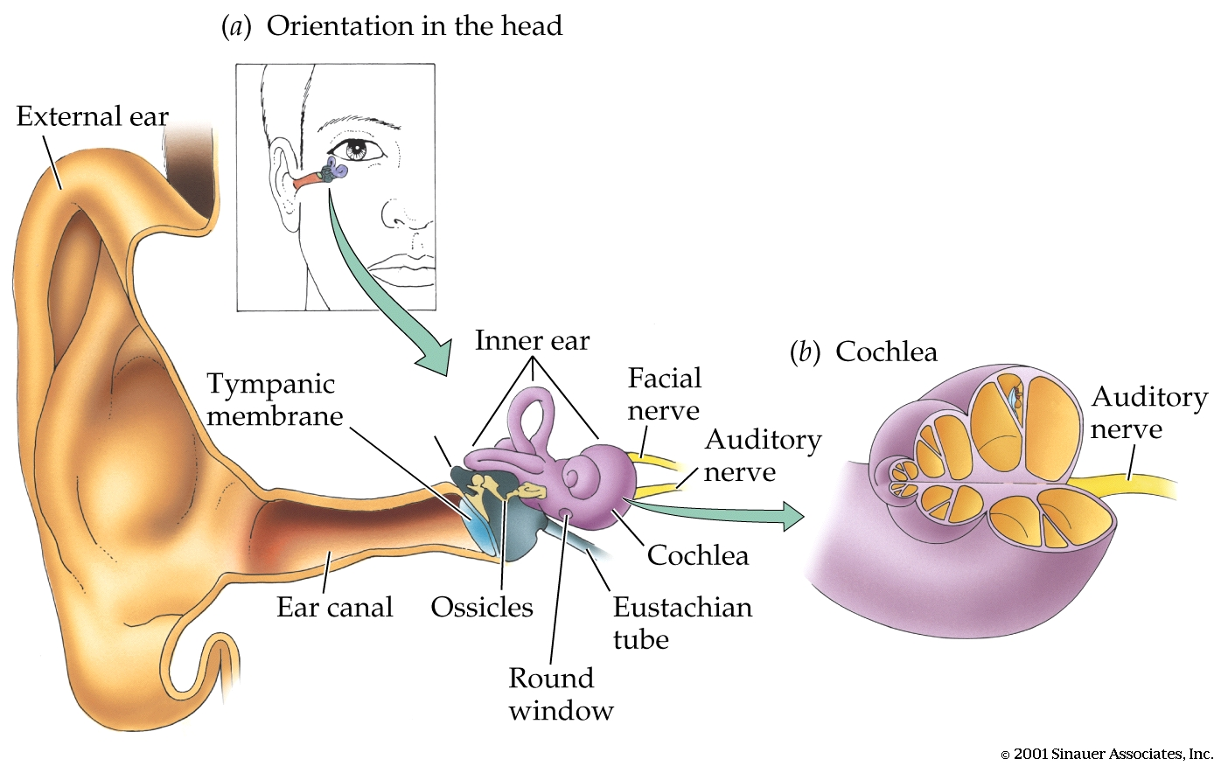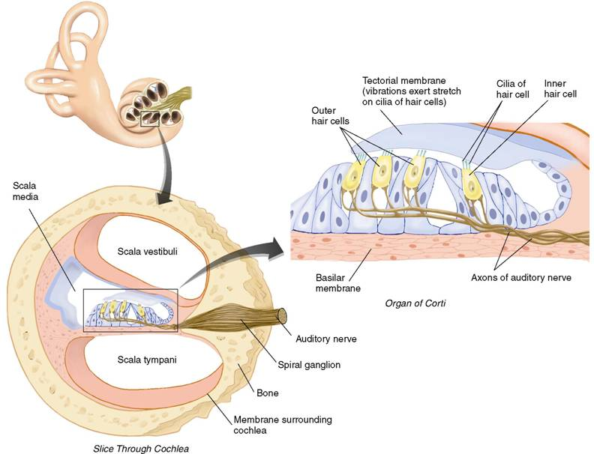

If there is time available, look at some of the rather beautiful electron microscopy pictures of inner ear (for example, semear12 Cochlea, apical coil (SEM); semear15 Cochlea, organ of Corti, outer hair cells (SEM).)
Psychophysics Demostrations. Go to PsyCog and open B5 (hearing, localization). Sound Localization: The brain uses two main cues for extracting information about the location of sound: inter-aural time difference (ITD) and inter-aural intensity difference (IID). For example, a sound originating in the left will arrive earlier at the left ear than at the right ear (ITD). Also, the sound originating from the left will be louder in the left ear than in the right ear because the skull acts as a shield. For a demonstration, go to Exp. B.5.1. For an explanation of how the brain recodes ITD into a spatial code, go to Fig B.5.1. To hear what all the buzz is about, go to Snd B.5.1
Vestibular system:
The vestibular system is the part of the inner ear that computes information about the position of the body in space (balance). The three semicircular canals compute information about dynamic changes in the 3-D (each canal provides input for one dimension). The vestibular sacs provide information about static position.
To see the vestibular system, go to Inner Ear (chinchilla) w82a. and open the link in the bottom left to a magnitude of 50x. In the leftside link, you will see a semicircular canals with its ampulla. In the rightside link, you see the macula of a vestibular sac, with receptor cells that have calcium carbonate crystals on top of them. You can see those same crystals in an electronic microscope picture (Semear2 Inner ear, vestibular apparatus).
