This week’s lab has several parts;

- Anatomy of Somatosensory System
- Touch
- Taste

1. Somatosensory System
The skin is the largest sense organ of the body and is innervated by many different types of receptors. Nerve impulses transmitted over the somatic pathways mediate sensations of touch, pressure, pain, temperature, vibration, tickle, and itch. In this lab you will explore the relative abundance of touch receptors on three different areas of the body and analyze the relation between receptor density for touch and the two-point threshold.

A. Anatomy
In the anatomical model of the brain, identify
• Primary somatosensory cortex
• Thalamus
• Internal capsule .

In the web, go to the main page of the brain atlas and choose Neurosyllabus -> 5.Somatosensory -> 14 Medial Lemniscus. At this coronal section of the brain, notice the input from the spinal cord to the thalamus. In the next image, 15.Ventral Posterior Nucleus, you should see the projections from the thalamus to the somatosensory cortex. Click on 22.movies and at the somatosensory radiations 3-D movie.
Next, click on 23.MRI Serial Section to see 5.Substantia Nigra. In this coronal section, identify the thalamus, the internal capsule, and the parietal cortex (somatosensory cortex). Make sure to also identify the surrounding structures (corpus callosum, lateral ventricle septum, basal ganglia, lateral fissure, temporal lobe, hippocampus, lateral ventricle, pons).

Finally, click on 23.MRI Serial Section to see slice D + 7.8. In this horizontal section, identify the internal capsule and the thalamus, as well as surrounding structures (corpus callosum, septum, lateral ventricle, basal ganglia, insula, lateral fissure, frontal lobe, primary visual cortex).
Compare the horizontal and coronal cuts to the 3-D plastic model

2. Touch Discrimination
Sensory receptors for touch are not evenly distributed throughout the skin. The accuracy of two-point localization (i.e., the minimum spatial separation of two distinct points) has a high correlation with the amount of cortical representation of a particular skin area, and this in turn has been correlated with the amount of innervation that skin area receives.
Procedure:
- Be sure the subject keeps eyes closed at all times.
- You will be testing three areas of the body:
- - the volar (palm) surface of the forearm,
- - the fingertip, and
- - a third area of your choice (e.g. the back or the calf would be best).

To establish two-point thresholds, take two pens and gently touch two points to the subjects skin (try to touch simultaneously and with equal pressure). Begin with the points set about 8-10 cm apart, and gradually decrease the separation until about 7 in 10 presentations are judged correctly. The subject should respond “two” if she feels two distinct points, or “one” if she/he is unable to discern more than one unique point. Be sure to include several catch trials (presenting only one point).

Write down the distance for each of the 3 areas of the skin tested. How do the two-point discrimination thresholds differ across the three areas of the skin?

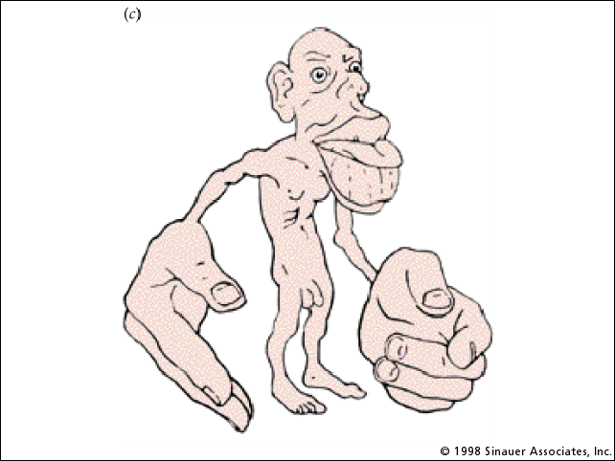

3.TASTE
A. Flavor: Olfaction + Taste
Taste and flavor are different. While you can taste only 5 things – sweet, salty, sour, bitter, fatty– you can identify thousands of flavors. This is because your nose adds smell to taste to create flavor. We will illustrate this by eating some Jelly beans.
- With your eyes closed, plug your nose and pop a jelly bean in your mouth.
- Chew 5 times while holding your nose. What do you taste?
- Unplug your nose and keep chewing. What flavor do you experience?

B. Supertasters. “There's good taste, and according to scientists, there's supertaste. Blue food coloring is going to tell me where I lie on the continuum. Armed with a bottle of blue dye No. 1 and a Q-tip, I paint my tongue cobalt, swish some water in my mouth and spit into the bathroom sink. In the mirror I see a smattering of pink bumps—each hiding as many as 15 taste buds apiece—against the lurid blue background. Now I'm supposed to count how many of those bumps, called fungiform papillae, appear inside a circle a quarter-inch in diameter [the inner size of a 3 page reinforcement ring] .” (Mary Beckman, The Smithsonian). Answer: If you have more than 40 dots you’re a supertaster; between 20 and 40 dots is average;

