|  |
| --- |
| Human biology and Health  Science Project the papillae (bumps) of the tongue |
| **Figure 1.** In this close-up of a tongue you can see the papillae (bumps) that house the taste buds (Bladebot, 2006). |

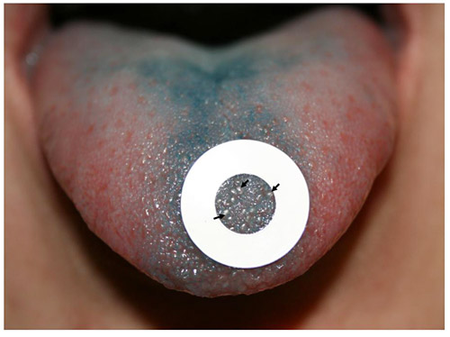

**Figure 2.** In this photo of a dyed tongue, the lighter-colored bumps are papillae. Black arrows point to three of the papillae. By counting the number of papillae inside the paper-hole reinforcer, you can determine if a person is a non-taster, an average taster, or a supertaster