**Anatomy**

Review directional terms – Draw arrow next to picture: Rostral, Caudal, Dorsal, Ventral, Medial, Lateral

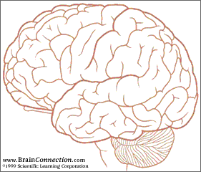

Identify planes in MRI image: Sagittal, Coronal, Horizontal

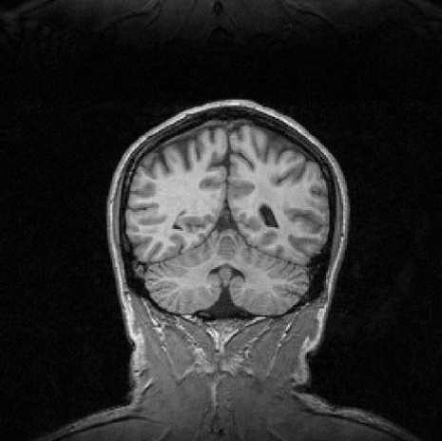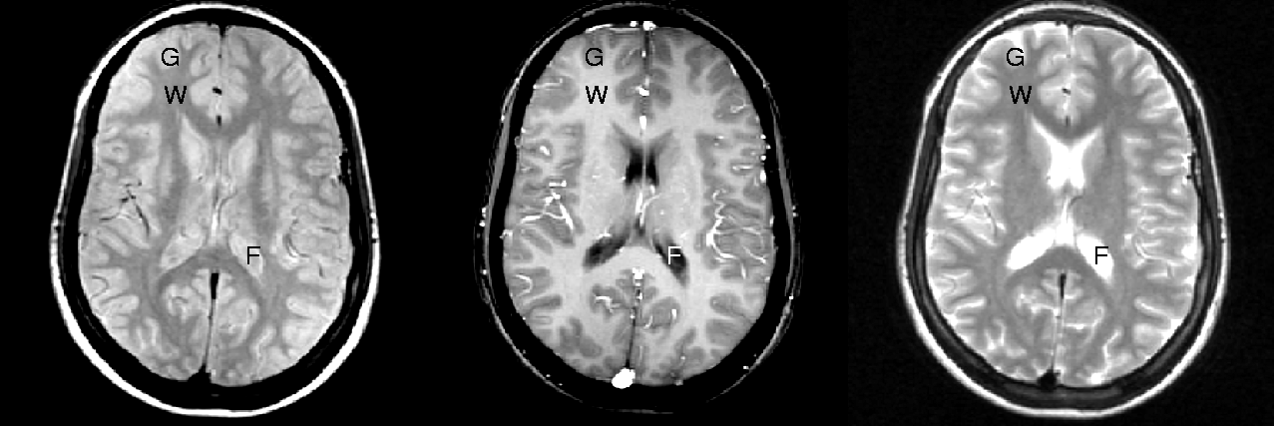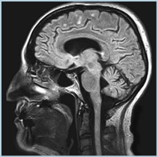

**Find the following structures or divisions on the brain model**

- Cortex­­­­­­/Lobes

Frontal __________________________________,

Parietal__________________________________,

Occipital__________________________________,

Temporal__________________________________

- Cerebellum __________________________________

Using a **mid-sagittal** view or on some part of the model, look for the following structures:

  corpus callosum__________________________________

  Anterior Cingulate, ventral part

Anterior Cingulate, dorsal part

Ventromedial prefrontal cortex

Dorsomedial prefrontal cortex

Ventro tegmental area

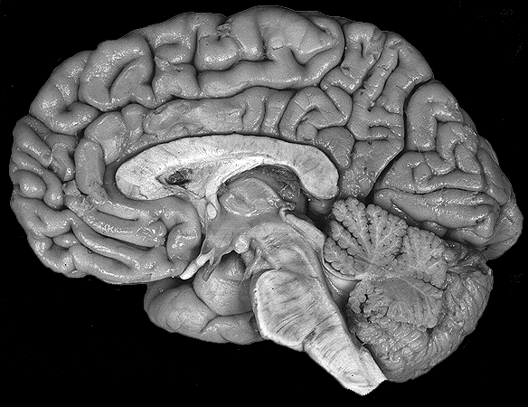

Using a **ventral view**, or on some part of the model, look for the following structures:

- Ventromedial prefrontal cortex

- Orbitofrontal cortex

-Anterior temporal pole

- Can you see the Face fusiform area? Why? Why not?

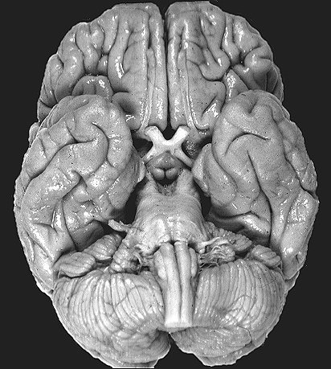

Using a **lateral view**, or on some part of the model, look for the following structures:

- Dorsolateral prefrontal cortex

- ventrolateral prefrontal cortex

- superior temporal gyrus

-Can you see the Insula? Why not?

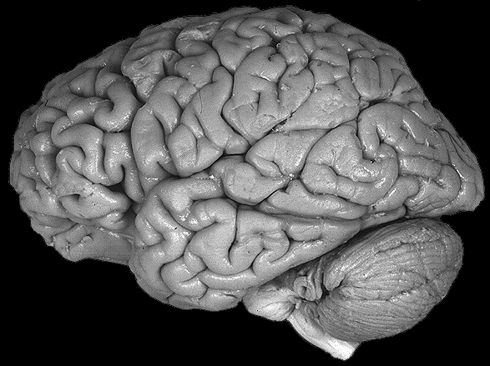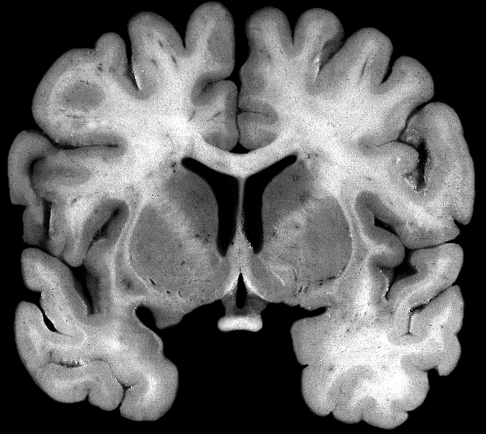

**What type of cut is this? __________**

Find:

* Ventral striatum (n. accumbens)
* Where amygdala would be
* Insula
* Temporal pole
* Corpus callosum
* Anterior cingulate

**Take a model apart, and find**

* Ventral striatum, nucleus accumbens
* Amygdala
* Hippocampus
* insula