Stop Perkiomen Township Supervisors From
Unethically Taking Away Elderly Residents Property!

Perkiomen Township supervisors are bringing to a vote whether or not they will force two of our beloved neighbors to sell their homes against their will under “eminent domain.”
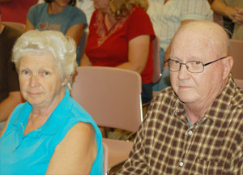

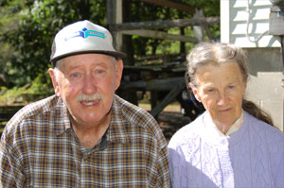
Lifelong Perkiomen residents Jim and Sue Umstead (14 Wartman, Collegeville) are being forced to sell their family’s farmhouse on 9.8 acres. Another 1.1 acre property near it sold for $130,000! Conservative estimates place their home and property value over $700,000! They are being unethically FORCED to accept a tiny fraction of that! Residents are up in arms and trying to call the community to action.
To make matters worse in this David vs. Goliath story, Mr. Umstead is fighting brain cancer. After the last township meeting he was so distraught he had a seizure and had to postpone his chemo treatment the following day.
When asked what they want to see happen in this situation, Mr. Umstead replied, “The Township has been badgering us for years to sell this property, and now it looks like they finally found their loophole. All I want to do is keep this property natural open space for my children and grandchildren to enjoy, along with our horses. I just wish there was some way this could all go away.”

Next to their property resides a disabled elderly couple, Jake and Janet Rawn (95 Koons), who can’t afford an attorney to fight this and are being forced to sell their house and 6.5 acres for $72,000! Residents are perplexed, trying to figure out how this could be happening!
Brian Jones, pastor of Christ’s Church of the Valley (www.moviechurch.com), the church where the Umsteads are parishioners, thinks this is a winnable fight. “I think what the Umsteads and Rawns have going for them is that basic human decency is on their side. It’s absolutely unconscionable what’s happening to them. In 20 years of being a pastor I’ve never seen anything like it. However, I know the people in this area well enough to know that when word gets out about this Township’s behavior it will stop dead in its tracks.”
In an open meeting on Tuesday, September 9th, Township supervisors said that they are pursuing this action because “the tenor of the community is that the residents want a new park.” But within a short distance of the Umstead property there are PLENTY parks already–Plank Road Park, the Township Building playground/park, the open fields across from the fire station, and the basketball courts/ball field at Cranberry (not to mention the playgrounds, ball fields, and tennis courts on the PV school property!).
There’s STILL TIME to stop this! Township supervisors have not voted yet and recently stated that if enough concerned citizens let them know they are opposed to this, they will stop! NOW IS THE TIME TO STAND UP!

